6) Based on the use case(s) and the set of class hierarchies, select an appropriate dynamic diagram and use the diagram to show how the objects collaborate to realize the use case. Note that there should be a clear connection among the use cases, class hierarchies, and dynamic diagram

USE CASE:
Ben Turner is looking to have a program that can calculate the value of used sporting product after inputting data such as original price, date of purchase, and current condition

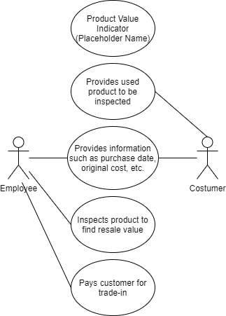

Class Hierarchy:

Inventory
Item
AmountOfItem
Date
getItem()
getAmountofItem()
getDate()
Value
Age
Original Cost
Shape it’s in (1-10)
AmountOfItem
PrevYearSales
getAge()
getOriginalCost()
getQuality()
getTotalItems()
getPrevYearSales()

The Dynamic Diagram

